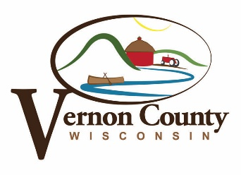

NOTICE OF VERNON COUNTY BOARD COMMITTEE MEETING
SOLID WASTE AND RECYCLING COMMITTEE AGENDA

The Solid Waste and Recycling Committee will meet at 9:30 A.M. on Wednesday
October 14th, 2020 at the Vernon County Solid Waste and Recycling Facility at S3705 County Road LF, Viroqua, WI.

- Call to order, Kelli Mitchell, Chair, presiding
- Roll call/Introduction of visitors by Committee Chair
- Affirmation of proper public notice of meeting
- Review and approve minutes of the September 9th, 2020 meeting
- Audience to visitors
- Discussion/ Possible Action Individual Tire Pricing
- Discussion/ Possible Action of Saturday Hours
- September Committee Report
- Review and Approve Vouchers
- Committee members reports/questions – Non-action items
- Department activity update – Non-action item
- Announcements
- Set next meeting date
- Adjourn

The SW/R Committee will meet at 9:30am on October 14th, 2020 at the Vernon County Solid Waste and Recycling Facility at S3705 County Road LF, Viroqua, WI. Agenda items include: Individual Tire Pricing, Saturday Hours, September Committee Report, Review and Approve Vouchers, Committee Members Reports/Questions, and Department Activity Update.

Guidelines for Public Participation at Committee Meeting
- Public participation must be limited to the “Audience to Visitors” agenda line unless a request is made at that time to speak during a different agenda line and is authorized by the Committee Chair
- Please state name and address
- Please limit comments to 4 minutes
- Please state subject to be presented
- Personal attacks or comments are out of order and will be so ruled by the chair
- Questions may be presented and become part of a discussion or agenda item at the next committee meeting if requested and appropriate for committee discussion and action
- No action will be taken on public participation comments during the “Audience to Visitors” agenda line. Items for discussion may be placed on a future board agenda
- Committee members may respond to questions or information requests personally or in writing following the meeting

COMMITTEE MEMBERS
Kelli Mitchel, Shawn Redington, Lorn Goede, Mary Rae, David Strudthoff

